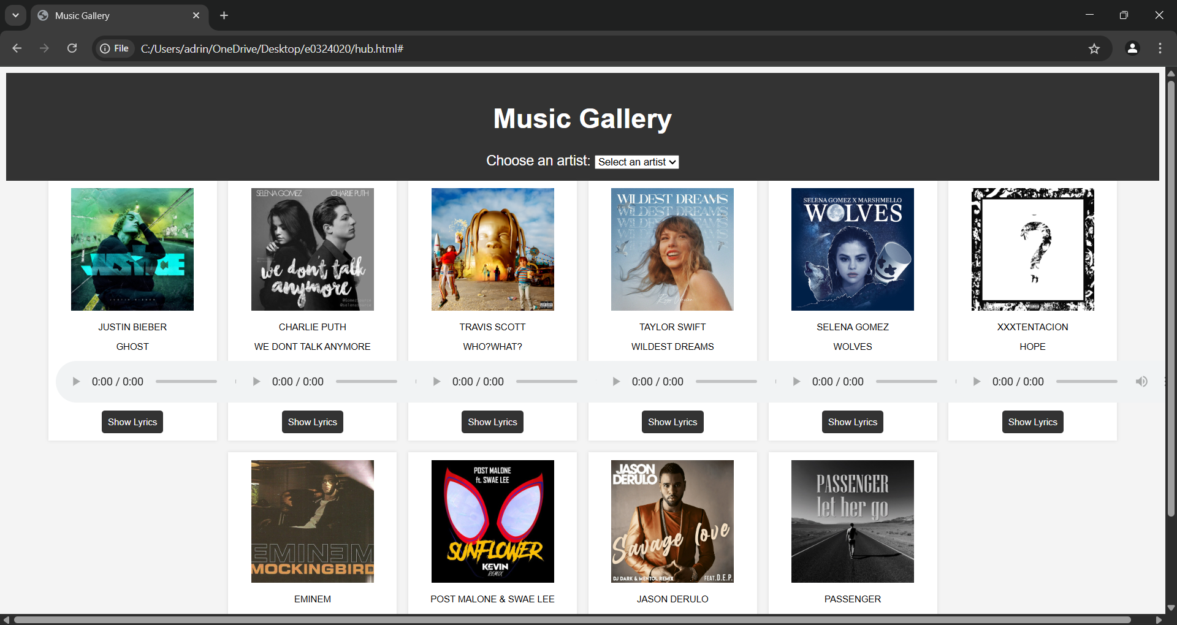

HTML:
<!DOCTYPE html>
<html lang="en">
<head>
<meta charset="UTF-8">
<meta name="viewport" content="width=device-width, initial-scale=1.0">
<title>Music Gallery</title>
<link rel="stylesheet" href="oops.css">
</head>
<body>

<header>
<h1>Music Gallery</h1>
<label for="artist-select">Choose an artist:</label>
<select id="artist-select">
<option value="" disabled selected>Select an artist</option>
<option value="artist1">Artist 1</option>
<option value="artist2">Artist 2</option>
<option value="artist3">Artist 3</option>
<option value="artist4">Artist 4</option>
<option value="artist5">Artist 5</option>
<option value="artist6">Artist 6</option>
<option value="artist7">Artist 7</option>
<option value="artist8">Artist 8</option>
<option value="artist9">Artist 9</option>
<option value="artist10">Artist 10</option>
</select>
</header>

<div class="gallery">
<!-- Looping Through Artists 1 to 10 -->
<div class="album" data-artist="artist1">
<img src="D:\summa\ae3c78d485c51675dcbfa1653910ee0c.1000x1000x1.png" alt="Album 1">
<p>JUSTIN BIEBER</p>
<P>GHOST</P>
<audio controls>
<source src="song1.mp3" type="audio/mp3">
</audio>
<a href="#lyrics1" class="lyrics-btn">Show Lyrics</a>
</div>
<div class="album" data-artist="artist2">
<img src="D:\summa\MV5BNmFlOWJkOTUtMzk5Ni00YjcxLTkyZTAtZjg5NmIzMTRkNjZkXkEyXkFqcGc@._V1_FMjpg_UX1000_.jpg" alt="Album 2">
<p>CHARLIE PUTH</p>
<P>WE DONT TALK ANYMORE</P>
<audio controls>
<source src="song2.mp3" type="audio/mp3">
</audio>
<a href="#lyrics2" class="lyrics-btn">Show Lyrics</a>
</div>

<div class="album" data-artist="artist3">
<img src="D:\summa\cbad795cdb3843247073fac8af76b117.1000x1000x1.png" alt="Album 3">
<p>TRAVIS SCOTT</p>
<P>WHO?WHAT?</P>
<audio controls>
<source src="song3.mp3" type="audio/mp3">
</audio>
<a href="#lyrics3" class="lyrics-btn">Show Lyrics</a>
</div>

<div class="album" data-artist="artist4">
<img src="D:\summa\artworks-qiMYWHUGdKjIx8BS-qAorhQ-t1080x1080.jpg"alt="Album 4">
<p>TAYLOR SWIFT</p>
<P>WILDEST DREAMS</P>
<audio controls>
<source src="song4.mp3" type="audio/mp3">
</audio>
<a href="#lyrics4" class="lyrics-btn">Show Lyrics</a>
</div>

<div class="album" data-artist="artist5">
<img src="D:\summa\Selena_Gomez_and_Marshmello_Wolves.jpg" alt="Album 5">
<p>SELENA GOMEZ</p>
<P>WOLVES</P>
<audio controls>
<source src="song5.mp3" type="audio/mp3">
</audio>
<a href="#lyrics5" class="lyrics-btn">Show Lyrics</a>
</div>

<div class="album" data-artist="artist6">
<img src="D:\summa\ab67616d0000b273806c160566580d6335d1f16c.jpg" alt="Album 6">
<p>XXXTENTACION</p>
<P>HOPE</P>
<audio controls>
<source src="song6.mp3" type="audio/mp3">
</audio>
<a href="#lyrics6" class="lyrics-btn">Show Lyrics</a>
</div>

<div class="album" data-artist="artist7">
<img src="D:\summa\artworks-tytpb8oaL5Wb9uIU-4YH59g-t500x500.jpg" alt="Album 7">
<p>EMINEM</p>
<P>MOCKINGBIRD</P>
<audio controls>
<source src="song7.mp3" type="audio/mp3">
</audio>
<a href="#lyrics7" class="lyrics-btn">Show Lyrics</a>
</div>

<div class="album" data-artist="artist8">
<img src="D:\summa\artworks-C9Iaa8IBy9cQ064Y-VsPIHg-t500x500.jpg" alt="Album 8">
<p>POST MALONE & SWAE LEE</p>
<P>SUNFLOWER</P>
<audio controls>
<source src="song8.mp3" type="audio/mp3">
</audio>
<a href="#lyrics8" class="lyrics-btn">Show Lyrics</a>
</div>

<div class="album" data-artist="artist9">
<img src="D:\summa\a1760939543_10.jpg" alt="Album 9">
<p>JASON DERULO</p>
<P>SAVAGE LOVE</P>
<audio controls>
<source src="song9.mp3" type="audio/mp3">
</audio>
<a href="#lyrics9" class="lyrics-btn">Show Lyrics</a>
</div>

<div class="album" data-artist="artist10">
<img src="D:\summa\artworks-000072949032-1fgfx8-t500x500.jpg" alt="Album 10">
<p>PASSENGER</p>
<P>LET HER GO</P>
<audio controls>
<source src="song10.mp3" type="audio/mp3">
</audio>
<a href="#lyrics10" class="lyrics-btn">Show Lyrics</a>
</div>
</div>

<!-- Lyrics Modals for Each Artist -->
<div id="lyrics1" class="modal">
<div class="modal-content"><a href="#" class="close">&times;</a><h2>Lyrics of Song 1</h2><pre><p>Young blood thinks there's always tomorrow
I miss your touch on nights when I'm hollow
I know you crossed a bridge that I can't follow
Since the love that you left is all that I get
I want you to know that
If I can't be close to you, I'll settle for the ghost of you
I miss you more than life (more than life)
And if you can't be next to me, your memory is ecstasy
I miss you more than life
I miss you more than life
Young blood thinks there's always tomorrow
I need more time, but time can't be borrowed
I'd leave it all behind if I could follow
Since the love that you left is all that I get
I want you to know that
If I can't be close to you, I'll settle for the ghost of you
I miss you more than life (yeah)
And if you can't be next to me, your memory is ecstasy (whoa)
I miss you more than life
I miss you more than life
Whoa-oh-oh
Na-na-na
More than life, oh
So if I can't get close to you, I'll settle for the ghost of you
I miss you more than life
And if you can't be next to me, your memory is ecstasy
I miss you more than life
I miss you more than life</p></pre></div>
</div>

<div id="lyrics2" class="modal">
<div class="modal-content"><a href="#" class="close">&times;</a><h2>Lyrics of Song 2</h2><p>Here are the lyrics...</p></div>
</div>

<div id="lyrics3" class="modal">
<div class="modal-content"><a href="#" class="close">&times;</a><h2>Lyrics of Song 3</h2><p>Here are the lyrics...</p></div>
</div>
</body>
</html>

CSS:

body {
font-family: Arial, sans-serif;
text-align: center;
background-color: #f4f4f4;
}

header {
padding: 15px;
background-color: #333;
color: white;
font-size: 18px;
}

/* Updated Gallery Styling for Compact Layout */
.gallery {
display: flex;
flex-wrap: wrap;
justify-content: center;
gap: 15px; /* Reduced spacing */
}

/* Updated Album Box Styling */
.album {
width: 200px; /* Shrunk width */
padding: 10px; /* Reduced padding */
background-color: white;
box-shadow: 0px 0px 5px rgba(0,0,0,0.1);
text-align: center;
font-size: 12px; /* Smaller font */
}

/* Smaller Images */
img {
width: 80%; /* Shrunk image size */
height: auto;
}

/* Compact Button */
.lyrics-btn {
display: inline-block;
margin-top: 8px;
padding: 8px;
background-color: #333;
color: white;
text-decoration: none;
border-radius: 4px;
font-size: 12px;
}

/* Modal Styling */
.modal {
display: none;
position: fixed;
left: 0;
top: 0;
width: 100%;
height: 100%;
background-color: rgba(0,0,0,0.5);
}

/* Show modal when targeted */
.modal:target {
display: flex;
justify-content: center;
align-items: center;
}

/* Shrunk Modal Content */
.modal-content {
background-color: white;
width: 40%; /* Reduced width */
padding: 15px; /* Less padding */
box-shadow: 0px 0px 5px rgba(0,0,0,0.1);
text-align: center;
font-size: 12px; /* Smaller font */
}

/* Close Button */
.close {
display: block;
margin-top: 15px;
font-size: 20px; /* Shrunk font */
color: black;
text-decoration: none;
}

